Hereby is the first versions of the simplified simulation outputs.

In the following results, we do not change the money distribution. So, there is not any dynamics in economy situation of the agents. The only change, is changing the value distribution of the groups. For simplicity, we still use the name “cheap, standard, expensive” for the groups. The max population of each group is a **simulation parameter** that we set those to :

|  |  |  |  |
| --- | --- | --- | --- |
| group | cheap | standard | Expensive |
| Population | 30 | 10 | 5 |

We use only two abstract values which are Universalism and Power. We initialize the value thresholds from input parameters of the simulation. These thresholds for agents might be different. The number of agents who care more about one the values is an input parameter as well.

|  |  |  |
| --- | --- | --- |
| Total number of agents | Power-oriented agents | Universalist agents |
| 50 | 25 | 25 |

We define different scenario settings for the simulations to check our hypothesis about the relation between the group size, changing in group members, and changing norms.

The simulation starts with assigning this population to each group :

|  |  |  |  |  |  |
| --- | --- | --- | --- | --- | --- |
| cheap | | Standard | | Expensive | |
| universalism | power | universalism | Power | universalism | power |
| 12 | 0 | 0 | 0 | 0 | 3 |

The remaining agents start with being homeless.

Agents start the simulation with norm some default norms for each groups which are inputs of the simulation and we set those as follows:

|  |  |  |  |
| --- | --- | --- | --- |
|  | cheap | standard | Expensive |
| Donation percentage | "|donation| = 50"; | "|donation| = 30"; | "|donation| = 20"; |

Setting 1:

|  |  |  |  |
| --- | --- | --- | --- |
| group | Tick ±4 | Add/remove universalism | Add/remove power oriented agents |
| ***CHEAP*** | 20 | 0 | 1 |
| ***EXPENSIVE*** | 20 | 1 | 0 |
| ***CHEAP*** | 60 | 0 | 10 |
| ***EXPENSIVE*** | 60 | 2 | 0 |
| ***CHEAP*** | 100 | -1 | 0 |
| ***EXPENSIVE*** | 100 | 0 | -1 |
| ***CHEAP*** | 200 | -13 | 0 |
| ***EXPENSIVE*** | 200 | 0 | -1 |

As you can see in the table, we make two different changes first we added one member in tick 20 to group cheap and expensive. Then, we added 10 power-oriented agents to cheap group and 2 universalists to expensive group at tick 60. Then, we removed a lot of universalists (which were the majority of cheap group who made the norm of the cheap group) from cheap group to see how the norm will re-shape.

The population changes according what we defined as input. Even though there is no need to represent the graph, just to give visual ideas about group membership changes you can check the following graph:

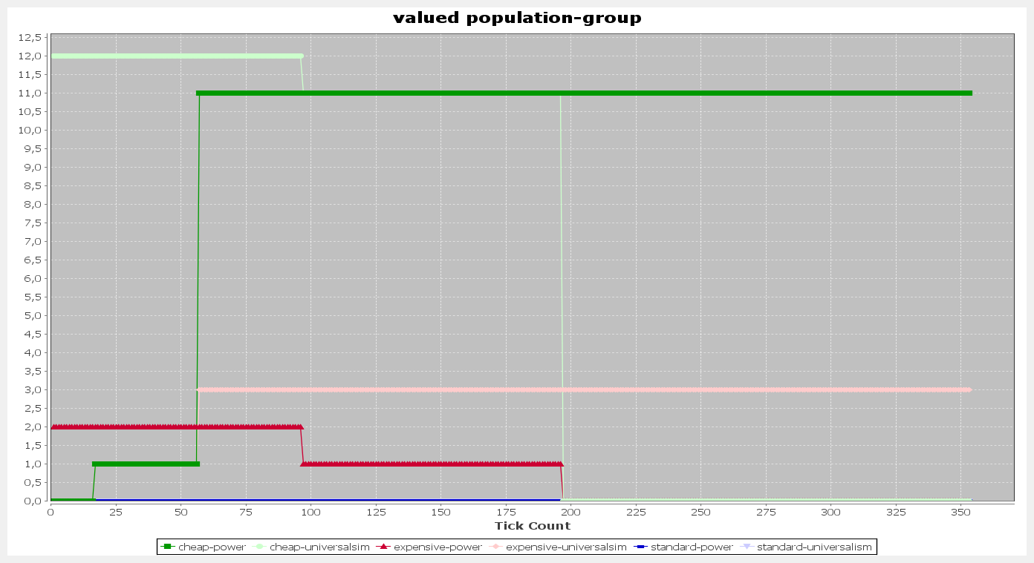

For this scenario setting, we get 3 different results (as the value based donation depends on how much the value is important for the agent. In other words donation ~ threshold

* The first kid of results is when the donation converge to a number.

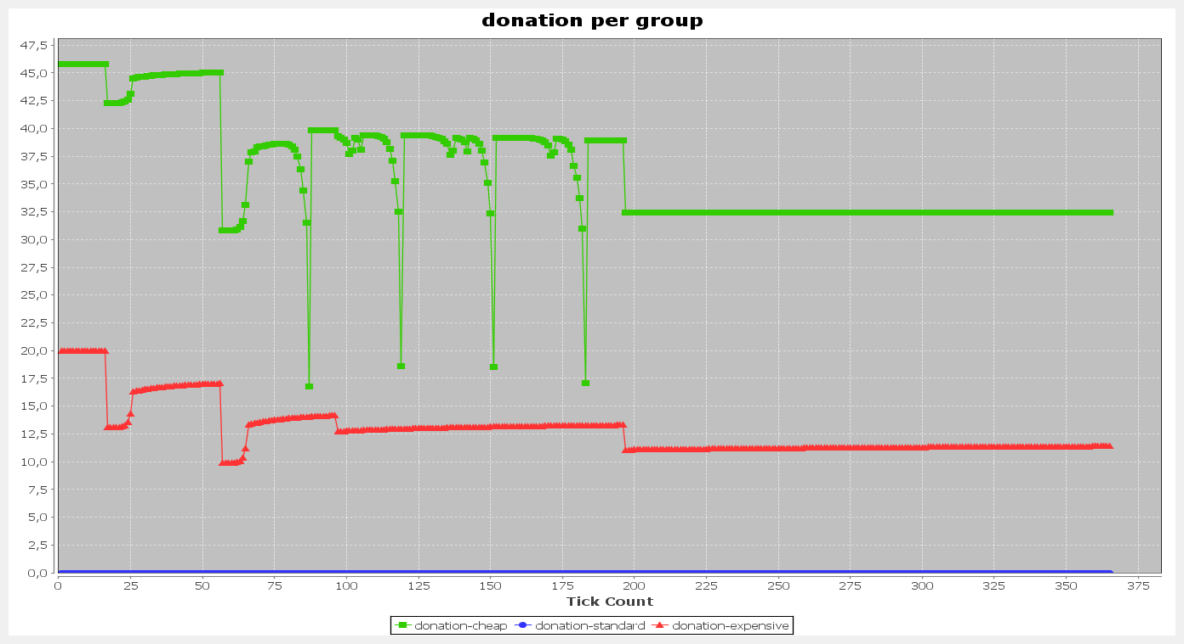

* Second kind of results, donation has low fluctuation

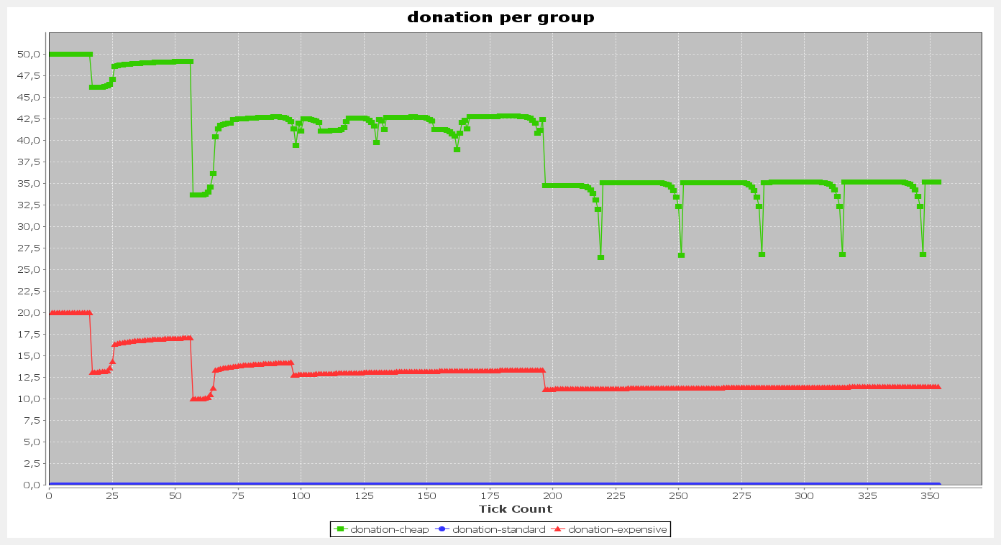

* Third kid of results in which donation has high fluctuation

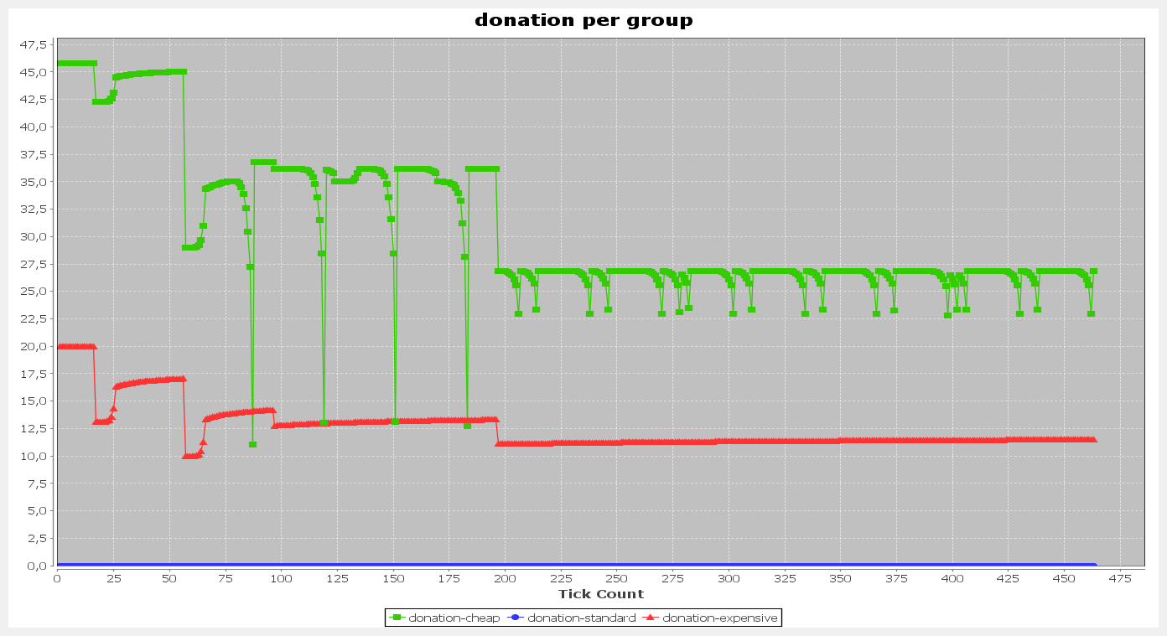

In all of the 3 kind of results, we can see one pattern. Donation amount decreases in cheap neighborhood. This happens even after many universalists who created the norm left the group. Means that the previous members stick to the norm of their group! But, they want to keep satisfying their values as well! So, they make some amount between the group norm and their personal values.

Also, we can see that when the population doesn’t change in expensive neighborhood, the donation amount increases with very slow slop! I believe it is because of group size. As adding or removing even one member, might change the value distribution of the group. The changed group takes it’s time to come up with a donation amount that satisfies all the members.